Table of Contents

Why do we need docker? 2

What can it Do? 3

What are containers 4

Operating system 4

Sharing the Kernel 5

Containers Vs Virtual Machines 5

Containers and Virtual machines 6

How is it done 7

Container Vs Images 8

Docker in DevOps 8

Docker Editions 9

Docker Container Command 10

Run - start a container 10

Run - attach and detach 10

RUN - STDIN 11

Run - PORT mapping 12

RUN - Volume mapping 13

Inspect Container 14

ENV Variables in docker 14

STOP - Stop a container 14

Rm - Remove a container 14

Exec - execute a command 14

Container History 15

Docker Image Command 15

CMD Vs ENTRYPOINT 17

Way to specify the command when container starts 19

NETWORKING 22

Embedded DNS 24

Docker Storage 24

File System 24

Layered architecture 25

Volumes 28

Docker Compose 29

Sample Application – Voting application 30

Docker compose -versions 33

Docker registry 35

Docker Engine 37

Containerization 37

Docker on Windows 39

Windows containers 41

Container Orchestration 42

Docker swarm 43

Kubernetes 45

# Why do we need docker?

There are certain instances where we have to work on multiple software or services and those software are compatible to different versions of OS. So, compatibility of version with underline OS was an issue. Secondly, we have to check the compatibility of the services and the library of the OS. We have an issue when one service requires one version of the library and another service require another version of library. The architecture of our application will keep on changing over time to work with all the services. If any version changes, we have to go back and find the compatible version of library. This compatibility matrix issue usually refers to **THE MATRIX FROM HELL.**  
And every time we have to follow a large set of instruction/commands to setup the environment and have to make sure they are using the correct version of the OS and the services because our application is tightly coupled with the version.  
We have multiple environment and there may be chance that different environment is using different OS version. So, we could not guarantee that the application we are building will behave the same way in all the environment.

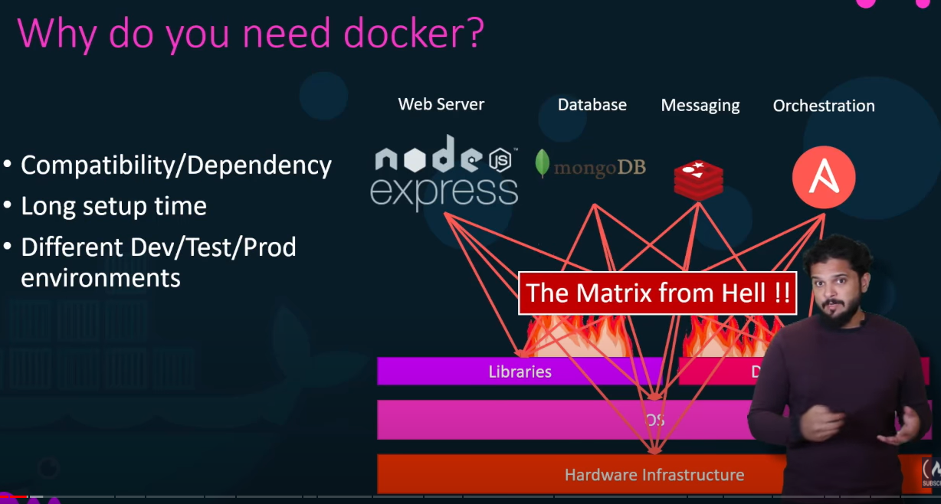

# What can it Do?

Docker is something which could help us with the compatibility issue and something that will allow us to modify or change these components without affecting the other component and even modifying the underlying OS.  
With docker we can run each component into a separate container with its own dependencies and its own libraries on the same VM or the OS.

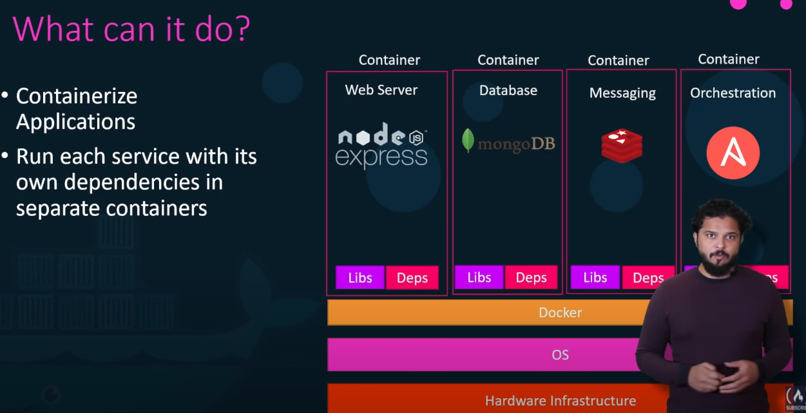

# What are containers:-

Containers are completely isolated environment as they can have their own processes and services, their own network interfaces, mounds just like virtual machine except they all shared the own OS kernel.

There are multiple types of containers, but Docker utilizes LXC containers.

Setting up these container environment is very hard as they are very low level that is where docker offers high level tool with several powerful functionalities making it really easy for end users.

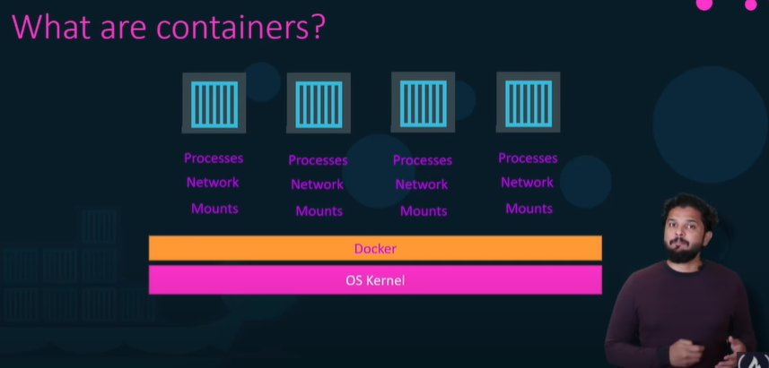

# Operating system:

All OS contains two thing, OS kernel and the set of software.

OS kernel is responsible for the interacting with underline hardware while the OS kernel remail same which is linux in this case, it’s the software above it that makes this operating system different. This software may consist of different user interface, drivers, compilers, file managers, developer tools etc. So we have common linux kernel shared across all OS and some custom software that differentiate operating system from each other .

Docker container shares the underline kernel.

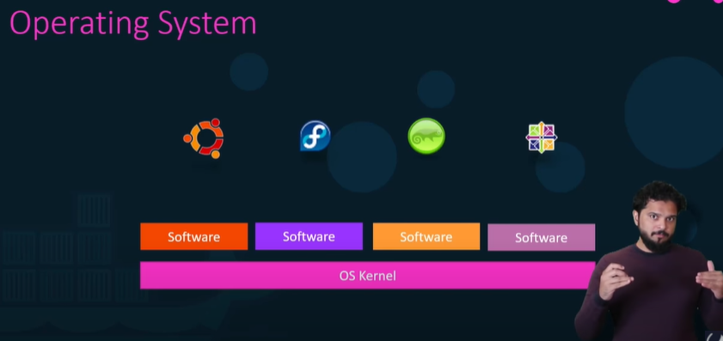

# Sharing the Kernel:

Let’s assume we have system with Ubuntu OS and Docker installed on it so docker can run any flavor of OS like debian, fedora, susi, centos on top of OS it as long as all based on the same OS kernel and in this case Linux.

If underline OS is ubuntu, docker can run container based on another distribution like Debian, fedora, susi, centos. Each docker container only has additional software that we have just talked about which makes the operating system different and docker utilizes the underline kernel of the docker host which works with all OSs above.

Windows don’t share the same kernel, so we won’t be able to run window based container on the docker host with linux on it, for that we required docker on the window server.

When we install docker on window and run a linux container on windows then we are not really running a linux container on window but window run a linux container on linux virtual machine. It’s like linux container on linux virual machine on window.

# Containers Vs Virtual Machines:

Virtual machine provides more isolation than containers.

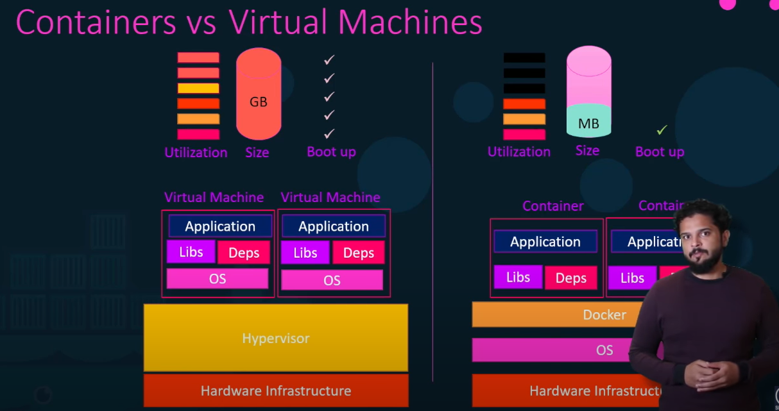

# Containers and Virtual machines:

We can often see container provisioned on virtual machine where we need a large environment with thousands of application containers running on thousands of docker hosts. By doing this we can utilize the advantages of both the technologies, we can use the benefits of virtualization to easily provision or decommission the docker host as required and at the same time make use of the benefit docker to easily provision the applications and quickly scale them as required.

But in this case we will not be provisioning that many VM as we used to before because earlier we provisioned VM for each application now we might provision a VM for hundred or thousands of containers.

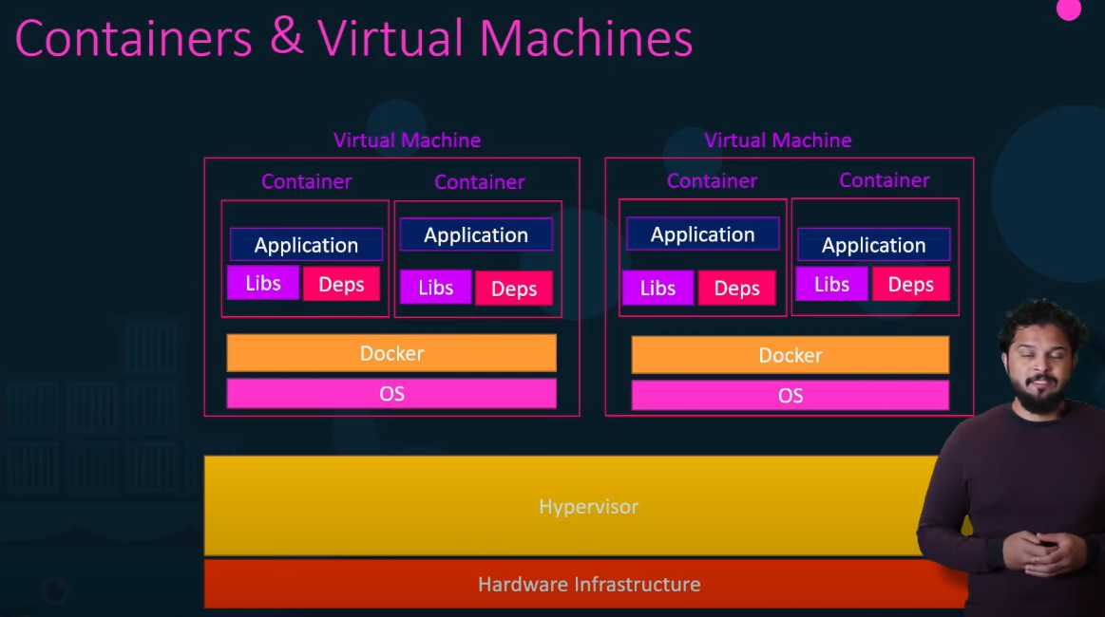

# How is it done:

We have docker public registry called dockerhub where we can get the image of the software and can run it easily. We can run multiple software and the multiple instance or the version of the software.

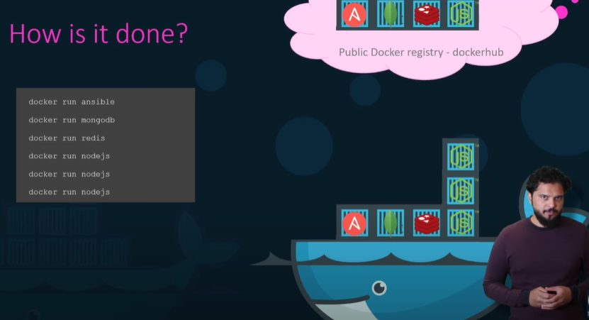

# Container Vs Images:

An image is a packer or the template just like a VM template which is used to create one or more containers.

Containers are the running instances of images that are isolated and have their own environment and the set of processes.

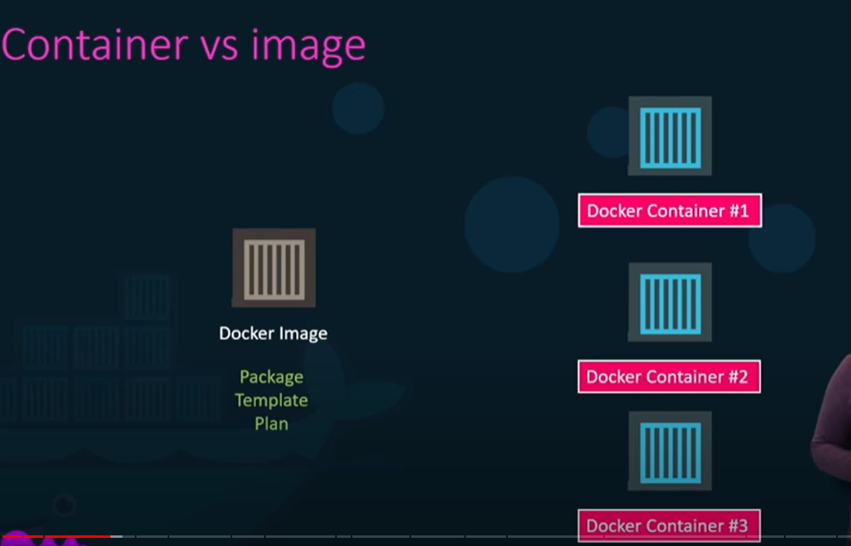

# Docker in DevOps:

Developer develops the application and handed over to the operation team to deploy and manage in different environment by sharing the set of instruction(such as info about how to setup host, what prerequisite to be installed on host, how the dependencies are to be configured etc) to do that.

Since ops team didn’t develop the application on their own so they struggle with setting it up.

With docker developer and operations teams work hand-in hand to transform the guide into a docker file with both of their requirements, this docker file is then used to create an image for their applications. This image can now run on any host with docker installed on it and ops team can use the image to deploy the application and it’s guaranteed that it will behave as the same way.

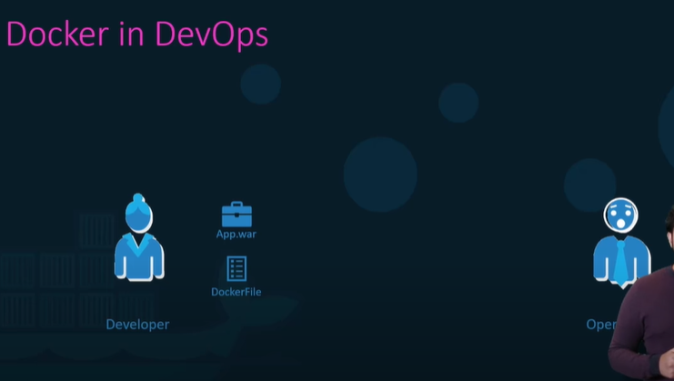

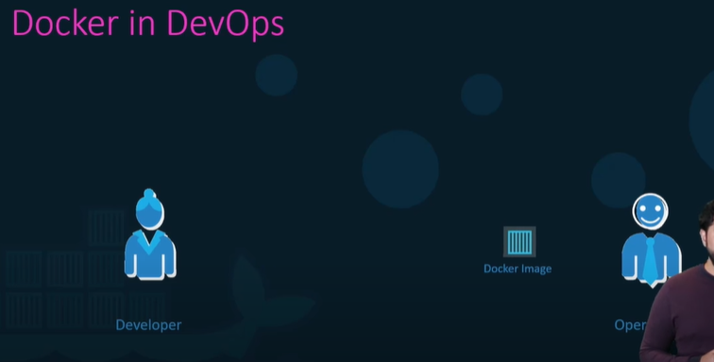

# Docker Editions:

1. Community Edition-Free products

2. Enterprise Edition- Paid(comes with image management, image security, container orchestration etc)

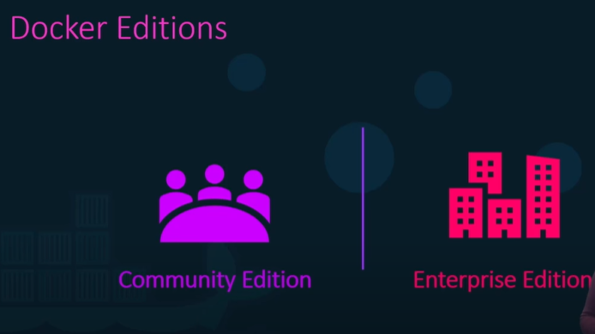

# Docker Container Command: -

## Run - start a container:

**docker run <image>** - it will run the instance of nginx application on the docker host if it already exist and if the image is not present on the host it will go out to docker hub and pull the image down. This is only done for the first time, for the subsequent execution the same will be reused.

**Docker run <image > <command>** - (example docker run ubuntu sleep 5) run an instance of ubuntu image with the process to sleep for 5 sec after that container will stop because it has no live process. Container runs only till they have any live process after that it automatically stops. Ex if we run "docker run ubuntu" command and then do "docker ps" we won't found any container running because ubuntu is an OS and we have not assigned any task so it runs the container and then stops the it. We can verify it by docker ps -a command.

## Run - attach and detach:

Suppose we have an image of web-app and do "docker run" command then container will run in the foreground or in attached mode means we will be attached to the console or the standard out of the docker container or will see the output of the web service on the screen. Won't be able to do anything other than viewing the output until the docker container starts and won't respond to our input (Ctrl+C to quit or stop the container and the application hosted on the container exists).

**Docker run -d <image_name>** - run the docker container in detached mode means run the docker container in background mode and we will be back to our prompt immediately and the container will continue to run in the backend. Can verify the "docker ps" command to view the running container.

**docker attach <container_id or container_name>** - to attach the running container

**docker run --name <container_name_that_want_to_give> <image_name>** - Create and run the container with provided container name. By default docker gives the name of the container.

**docker run <image_name>:<version>** - to run the container with specific version of application/image. By default latest version of image runs in the container. Ex "docker run redis:4.0". "redis:4.0" is called tag, default tag is latest. We can check this tag in dockerhub repo.

## RUN - STDIN:

**docker run -i <image_name>** - to run in interactive mode i.e can take the input from the terminal before running Ex docker run -i kodekloud/simple-prompt-docker(takes the input then run)

**docker run -t <image_name>** - to see the prompt. Ex docker run -t kodekloud/simple-prompt-docker

**docker run -it <image_name>** - to get the prompt then can take the input from terminal. Ex docker run -it kodekloud/simple-prompt-docker

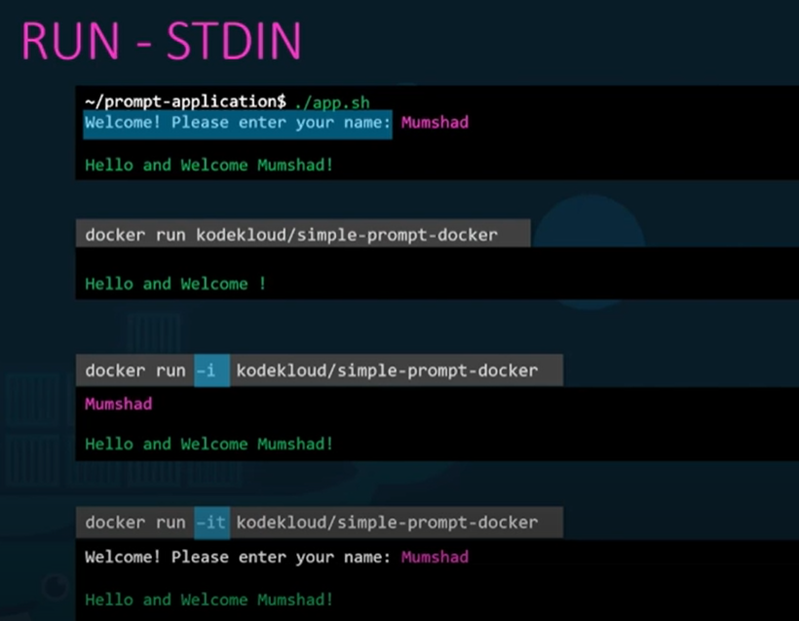

## Run - PORT mapping:

The system where docker installed is called docker host or docker engine.

**Docker run -p <external_port>:<internal_port> <image_name>** - Command to map external(docker host) to internal(docker container) port.

same application or container can run on multiple external port.

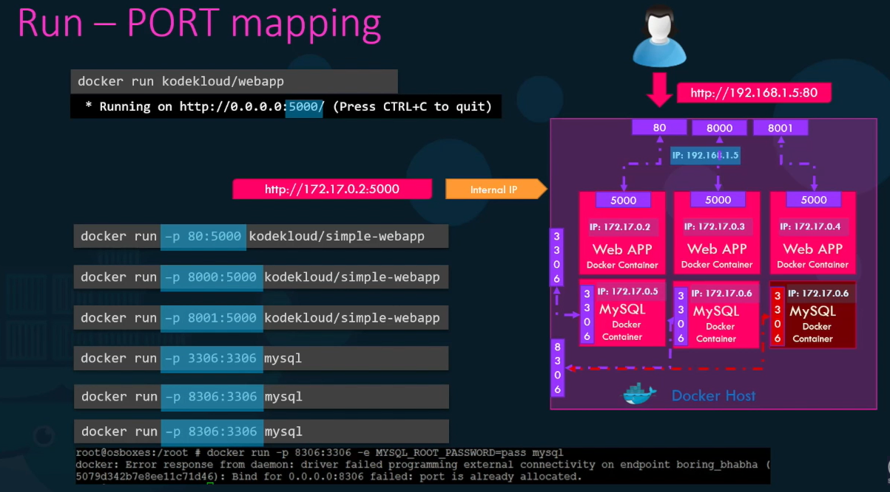

## RUN - Volume mapping:

When container deletes all the data stores in the container (container has it's isolated file system) will lost. Take an instance of mysql which is running as a docker container and suppose if we delete and remove the containers then all the data stored inside the mysql db will lost. To make the data persist we can map docker container's volume or data file to docker host volume i.e. all data of the container will be persist or stored in the docker host (external volume) if we delete the container. So in that way we won't loose the data.

**docker run -v <docker_host_dir>:<docker_container_file_system_or_dir> <image_name>** - Ex docker run -v /opt/datadir:/var/lib/mysql mysql

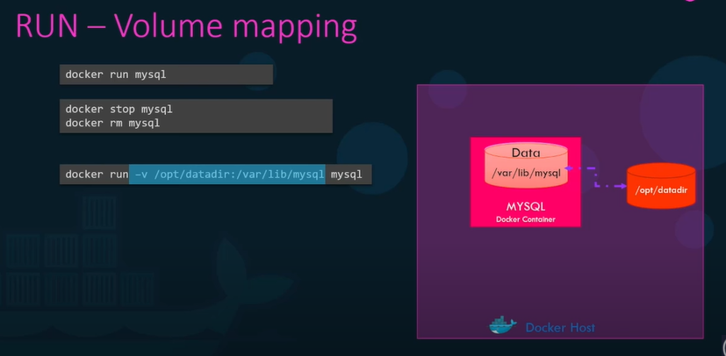

## Inspect Container:

**docker inspect <conatiner_id>** - returns the detailed container information, can also see the list of env variable set in the container while running.

## ENV Variables in docker:

**docker run -e <ENV_VARIABLE_NAME>=<ENV_VARIABLE_VALUE> <image_name>** - To run the container by setting environment variable. Ex docker run -e APP_COLOUR=blue simple-webapp-color

*ps - list containers:*

**docker ps** - list all running container with some basic info about them

**docker ps -a** - list all running or stopped/exited container

## STOP - Stop a container:

**docker stop <container_id or container_name>** - Stop the container specified with container id, on success we will see the container_name. but we can still see container using docker ps -a command. Container will stop but still consuming the memory, use rm command to get rid of that.

## Rm - Remove a container:

**docker rm <container_id or container_name>** - remove the stopped or exited container specified with name/id permanently. On successful it prints the container name back. We won't be able to see using docker ps -a command. Container will be removed but still we will have the image that we have downloaded.

## Exec - execute a command

**docker exec <container_id> <command>** - ex "docker exec distracted_mcclintock cat /etc/hosts" To execute te command inside or on the container

*Container Logs:*

**docker logs <image_id>** - to see the log of the application running inside the container

**docker logs -f <image_id>** - to see the running log in attached mode

**docker logs -f --tail=100 <image_id>** - to see latest 100 lines of running logs

## Container History:

**docker history <container_id>** - to see the history of the container from it started.

## **Docker Image Command:-**

*Images - List of images:*

**docker images** - see list of images present on our hosts with their size

*rmi - Remove images*

**docker rmi <image_name>** - permanently remove images from the docker host. Make sure all dependent containers are stopped and deleted before removing the image, otherwise won't be able to remove image.

*Pull - download an image*

**docker pull <image_name>** - it will only pull/download image from dockerhub repos and stores it on our host but won't run container. Whereas docker run command pull the image and run the container.

*Create my own image:*

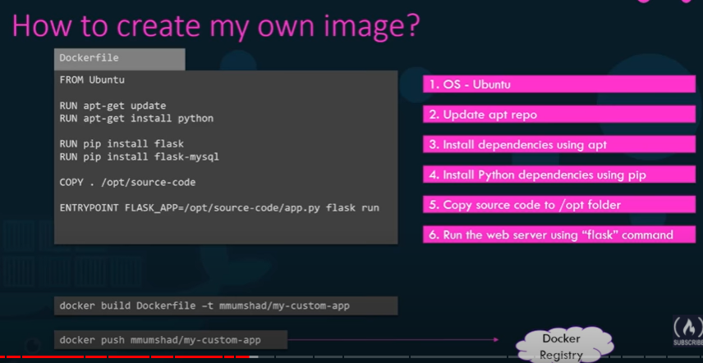

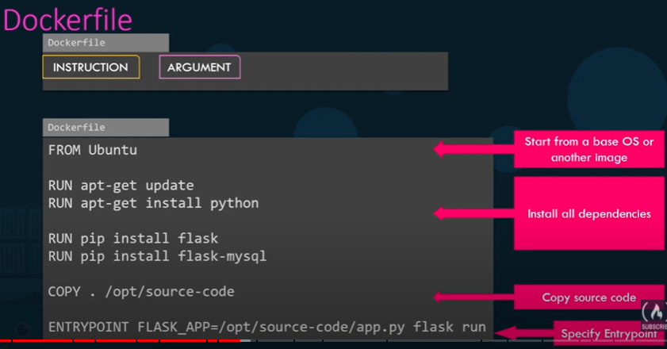

Layered architecture means next step will create on top of previous step.

Docker follow layered architecture because if docker build fails In any particular steps then we no need to build from the starting . We can restart building from particular step.

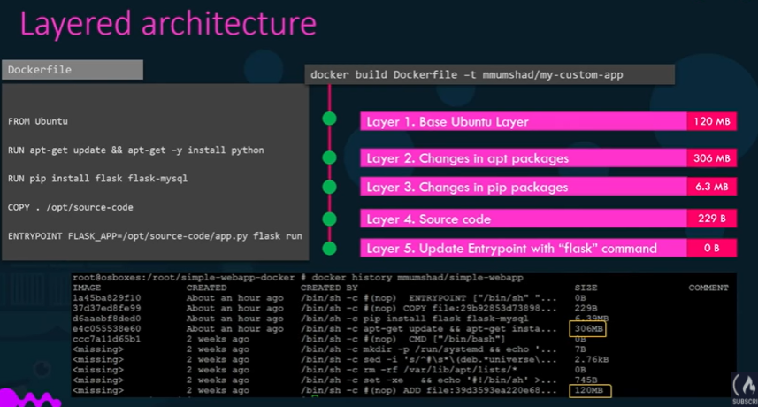

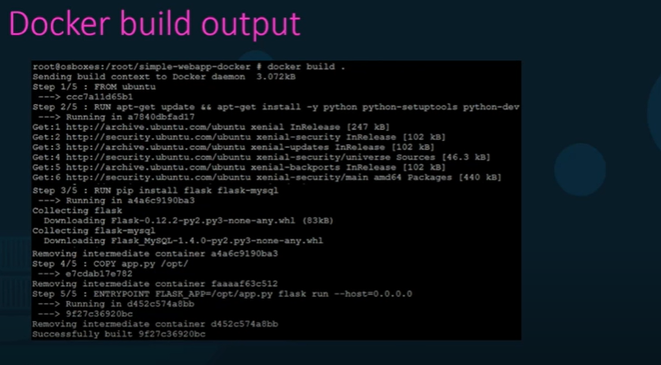

Docker building uses cache and stores the successful step into cache if any steps fail and rebuild the docker container then it uses the cache of the successful step and then proceed or if a new steps added then also it uses cache.

Suppose docker build failed in 3rd layer/step then during rebuilding it won't repeat step 1 and 2 rather than take from cache (see ss).

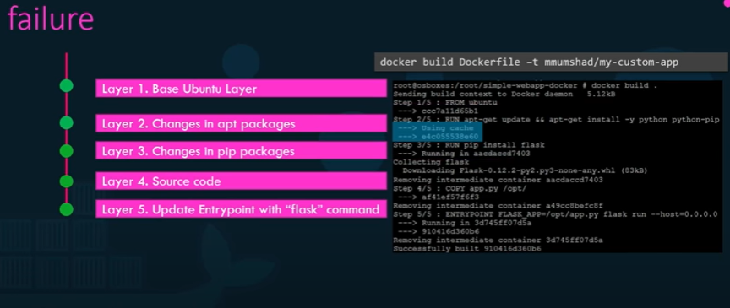

# CMD Vs ENTRYPOINT:-

When we run “docker run ubuntu” it runs the container and exits immediately, we wouldn’t see anything in “docker ps” but we can see in “docker ps -a” that ubuntu container ran and in exited state. This happened because unlike VM container are not meant to host OS but containers are meant to run specific task or process such as to host an instance of web server, application server, database or carry out some kind of computation and analysis once the task completes the container exists. A container only lives as long as the process inside is alive or running.

 Inside docker file we define what processes/command or program (in CMD instruction) that runs inside the container when it starts.

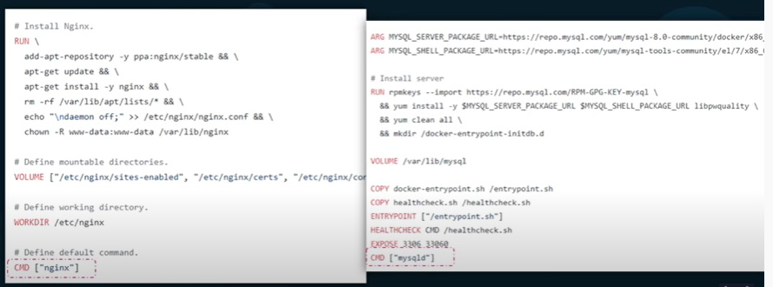

For the image of ubuntu dockerfile uses bash as the default command, now bash is not really a processes like a web server or database server, it is a shell that listen the input from a terminal. If it cannot find a terminal it exists. When we create container from ubuntu image, it creates the ubuntu container and launch the bash program, by default docker does not attach terminal to the container when it runs and so the bash program does not find the terminal and so it exits. Ans since the process that was stated when the container was created is finished so container exists as well.

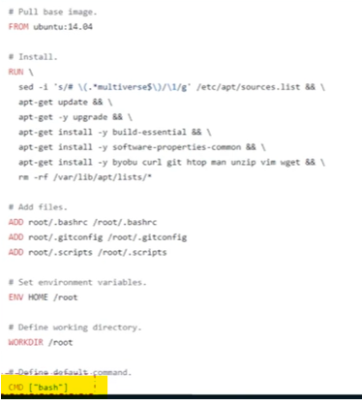

# Way to specify the command when container starts:-

**docker run ubuntu [command]** – It overwrites the command specified in dockerfile. Ex- “docker run ubuntu sleep 5” it run the sleep program when container starts and wait for 5 sec and then exits. But to make this change permanent we have to create our own image from the base ubuntu image and specify the new command in dockerfile.  
The different way to define the command like in **shell form or JSON array** format. But when we specify in JSON array format then the first element in the array should be the executable and the command and the parameter should be separate element in the list.

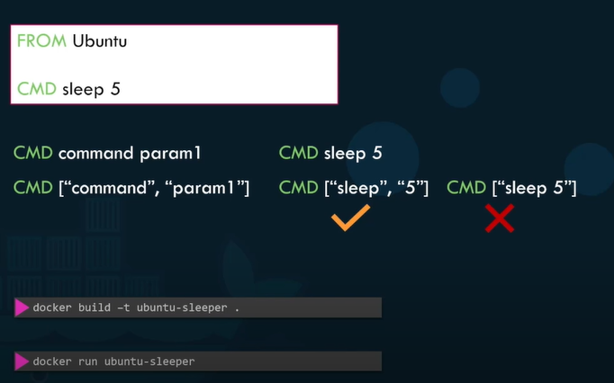

**ENTRYPOINT** instruction is like command instruction(CMD) and we can specify the program that will be run when the container starts and whatever we specify in the command line will get appended to the entrypoint.

**In case of the CMD instruction the command line parament we passed will get replaced entirely whereas in case of ENTRYPOINT the command line parameter will be appended.**

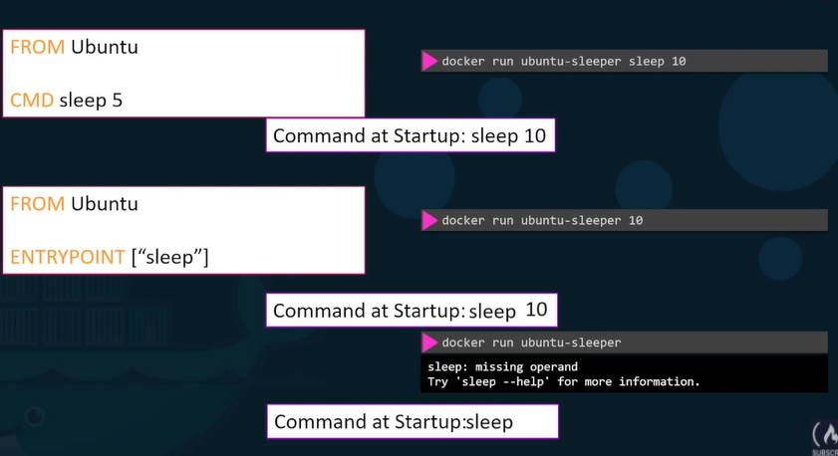

To configure the default value for the command if one was not specified, use both ENTRYPOINT as well as CMD instruction. If we don’t specify the command line then CMD instruction will appended to the ENTRYPOINT instruction and if we do then CMD instruction will overwrite with the command line. To use both we have to always specify CMD and ENTRYPOINT instruction in JSON format.

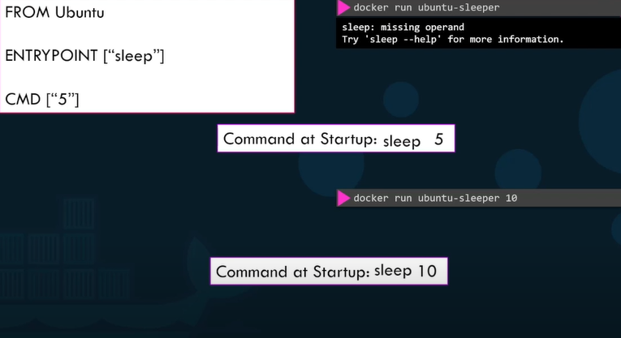

**docker run –entrypoint sleep2.0 ubuntu-sleeper 10** - To overwrite the ENTRYPOINT instruction use “—entrypoint” specify with instruction.

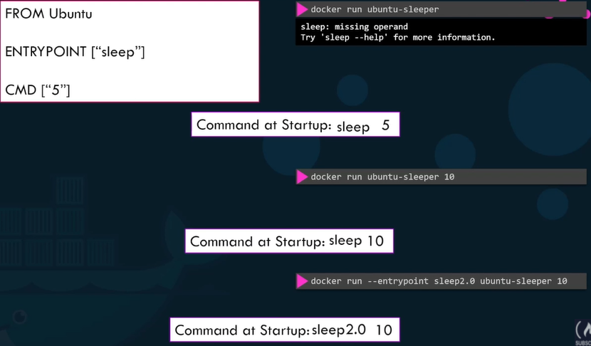

# NETWORKING:-

As we install docker it creates 3 networks automatically:

1. Bridge- It is a default network a container gets attached to. Bridge network is the private internal network created by docker on the host. All containers attached to this network by default and they get an internal ip address usually in the range 172.17 series. The container can access each other using this internal ip if required. To access any of these container map the external port of these containers to ports on docker host by using “docker run -p” command.

2.None – In the none network container are not attached to any network and does not have any access to the external network or other containers. They run in an isolated network.

3. Host- In host network container associate to the host network. This takes out any network isolation between the docker host and the docker container means if you were to run a web server on port 5000 in a webapp container it is automatically accessible on the same sport externally without requiring any port mapping as the web container uses the host network. This would also mean than unlike before we will now not be able to run multiple web containers on the same host on the same port as the ports are now common to all containers in the host network.

If we would like to associate the container with any other network, we need to specify the network information using the network command line parameter.

**docker run ubuntu** – to associate with bridge network.

**docker run ubuntu –network=none** - to associate with none network.

**docker run ubuntu --network=host** - to associate with host network.

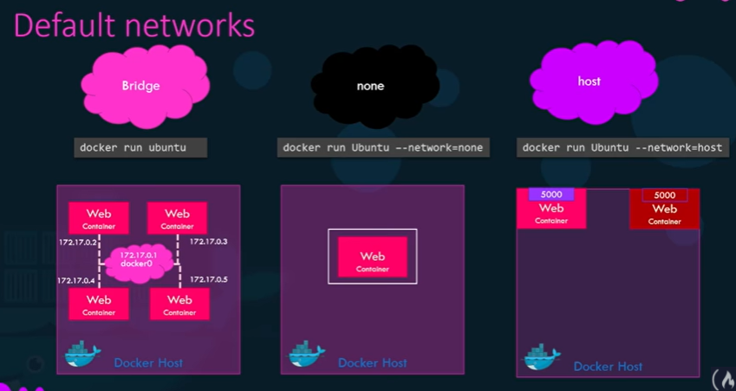

**User-Defined Networks:**

As we know in default network all containers are connected by default with the ip range 172.17, but we could create our own internal network using the command “docker network create” and specify the driver and the subnet of the network followed by network name.

**docker network ls** – to list all networks.

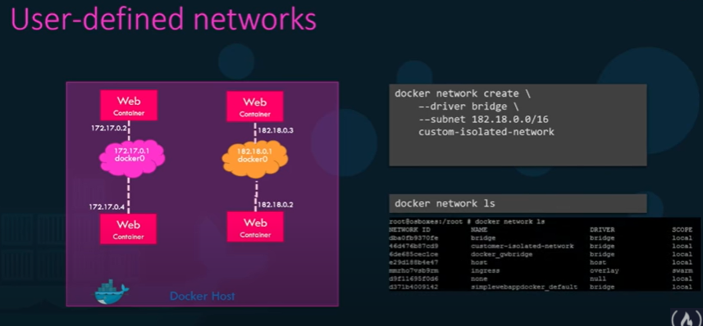

**docker inspect <network_name>** - to see the network setting and the Ip address assigned to an existing container, the type of network container is attached to and the mac address.

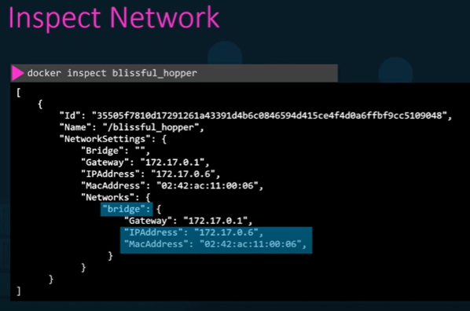

## Embedded DNS:

It is not guaranteed that container always get the same ip, it may change when system rebuild. So, it is not a good approach to use the container’s ip for inter container communication rather than we should always use the name of the container. All container in the docker host resolve each other with the name of the container. Docker has a build in DNS server which help the container to resolve each other using the container name. **Note- Build in DNS server always runs at 127.0.0.11.**

Docker uses network namespaces that creates a separate namespace for each container then uses virtual ethernet pairs to connect containers together.

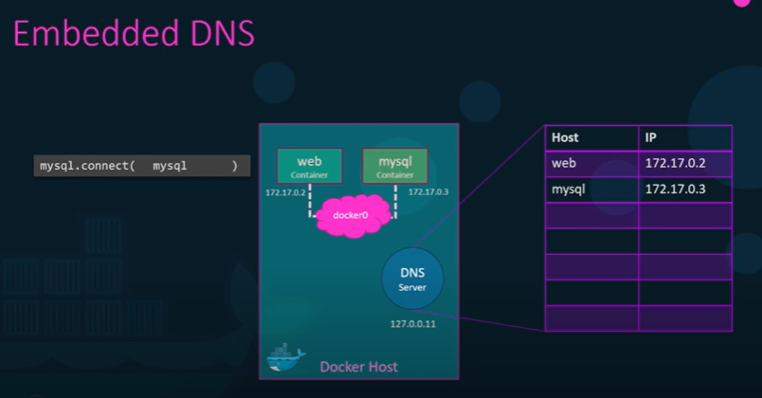

# Docker Storage:-

## File System:

As we install docker it creates folder structure /var/lib/docker.

Multiple folders are there inside lib which contains files related to image, container running on docker host. Files related to container are stored inside container folder and files related to images are stored inside image folder and any volumes created by docker container stores under volume folder.

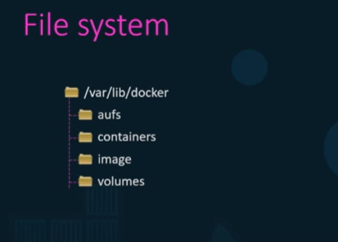

## Layered architecture:

Each line of instruction in the docker file creates a new layer in the docker image with just the changes from the previous layer. Since each layer only stores the changes from the previous layer so it is reflected in the size as well.

Suppose we have 2 docker file having first three step is command and we have already build the image of first application then while build the image of second application docker is not going to build first 3 layers since first 3 layer is already build in first application instead it reuses the same three layer it build for first application from the cache and only build the different step or layer. This way docker build images faster and efficiently and saves disk spaces as well. This is also application when we update our application code. Whenever we update our application code docker simply reuses all the previous layers from cache and quickly rebuilds the application image by updating the latest source code.

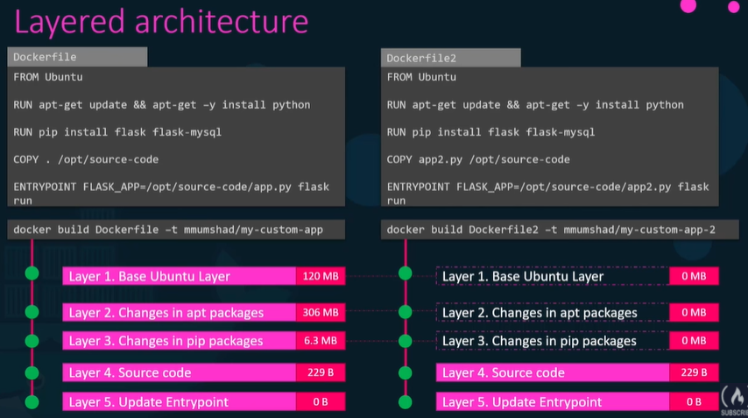

As we create image using docker build command, it will be read only hence we cannot make any changes once image is built (to make the changes we have to rebuild image) i.e. image layer is read only.

Docker creates container using image layer and once container layer gets created, we can make the changes i.e., it is writable which means we can store data created by container such as log files written by applications any temporary files generated by the container just any file modified by the user on that container. The life of this layer though is only as long as the container is alive when container is destroyed this layer and all of the changes stored in it are also destroyed.

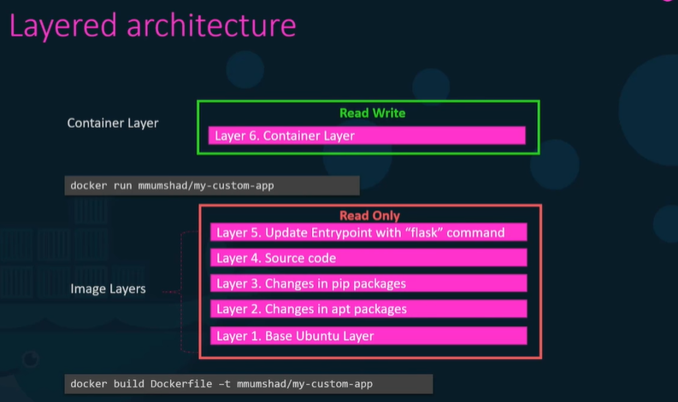

COPY-ON-WRITE –

When cannot modify the source code in image layer because it is read only but when we try to modify in container layer and save it then it creates a copy of the original file (from image layer) and save it into container layer and all modification will be done in this copy of the file in the readwrite layer. This is called COPY-ON-WRITE mechanism.

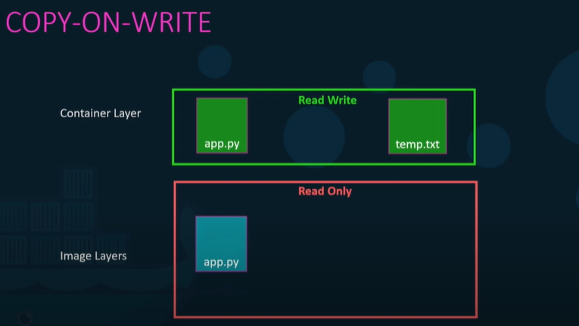

# Volumes:

As we know when we delete the container all the data we have inside the container will lost. If we wish to persist the data like we are working on the data-base container and we would like to preserve the data created by the container then we could add a persisted volume to the container by using “**docker volume create data_volume**” command which creates a data_voumme folder inside the /var/lib/docker/volumes then when I run the container we could mount the volume inside the docker container by using “docker run -v” command.

**Note-** If we didn’t create a data_volume folder inside the volume before running docker run -v command then by default docker creates this folder inside volume.

If we want to create my data as the location other than /var/lib/docker/volumes then we have to specify the exact path of the folder rather than giving only the folder name which is called bind mounting like shown in screenshot.

So, we have two kinds of mounting:

1. Volume mounting:- Volume mounts mount a volume from the volumes directory.

2. Bind mounting:- Bind mounts mount a directory from any location on the docker host.

**NOTE: New way of mounting is using mount rather than -v**

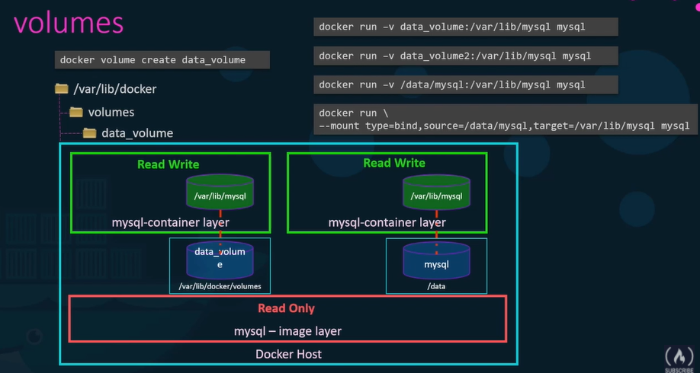

Docker uses **storage drivers** to enable layered architecture, maintaining layered architecture, creating a writable layer, moving files across layers to enable Copy on write etc. There are multiple storage drivers, and the selection of the storage driver depends on underline OS(like Ubuntu use AUFS)

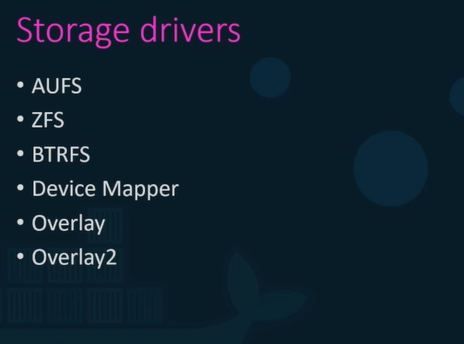

# Docker Compose: -

With docker compose we could create a configuration file in yml format called docker-compose.yml and put together different services and the options specific to this to running them in this file then we could simply run docker compost up command to bring up the entire application stack. It’s easier to implement run and maintain as all changes are always stored in the docker compost configuration file however this is all only application to run containers on single docker host.

**Docker-compose up –** to run docker compose file.

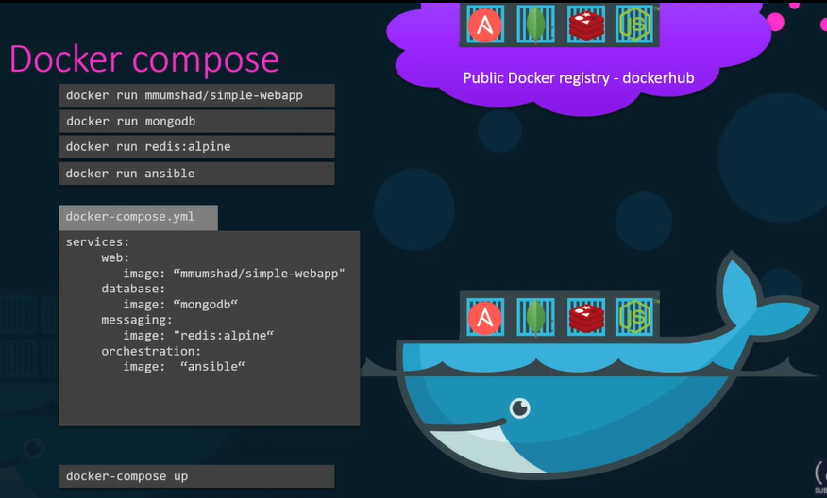

# Sample Application – Voting application:

Voting app- Developed in python. It is a user interface provide the option to choose between cat and dog.

In-memory db- it is a redis application store the data provided by voting app and pass to worker.

Worker- Developed in .net process the vote. Takes the vote and update the persistent database.

Db- it is PostgreSQL which stores the db.

Result-app -It is a user interface developed in nodejs which takes the data from DB and show to the user.

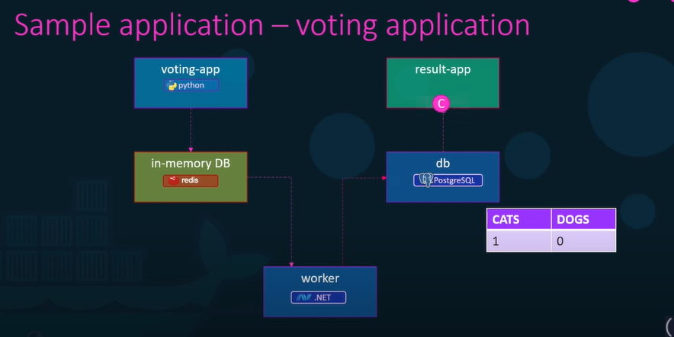

Above sample app build with the combination of different services , tools and multiple platform like python, node js, .net etc.

To make the application running we have to run docker run command for all the application (5 times) and with the port exposed and then link all the container because there could be multiple instances running for the same image so we have to tell the container that to which container they should communicate.

Below is giving **Internal server error** because we haven’t link.

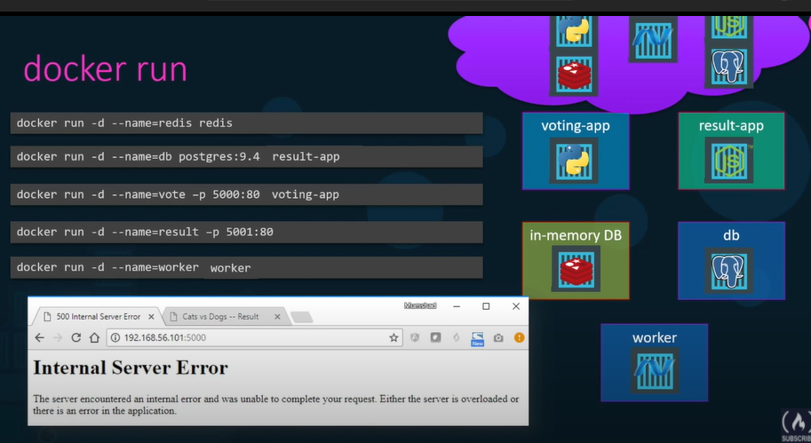

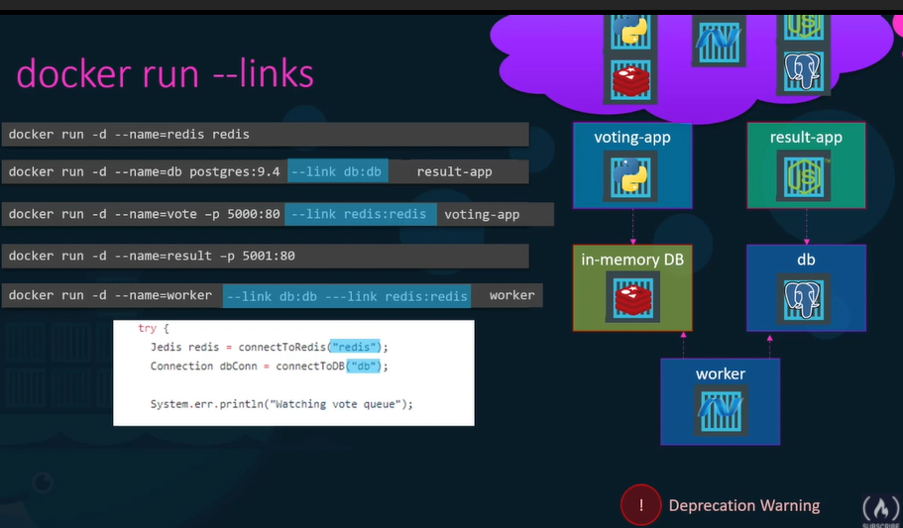

**NOTE: to use link this way is deprecated, docker swarm and network have better way of achieving it.**

**Create docker compose from docker run:**-

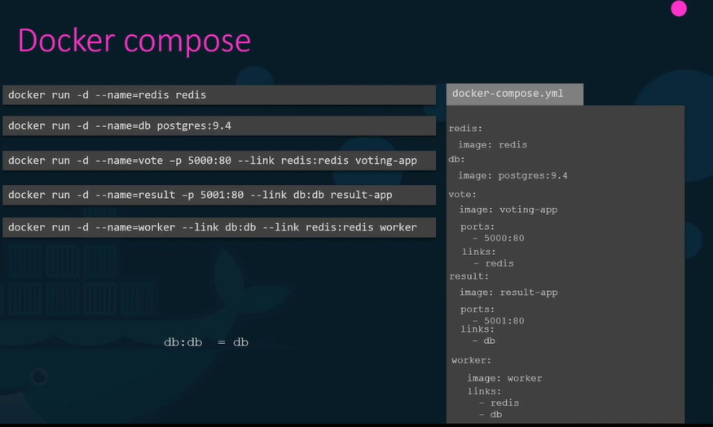

If we want to build the image(own application) before creating the container then we can replace image line in the docker compose file to the build line mentioning the location of the directory which contains the application code and jenkinfile with instruction to build image

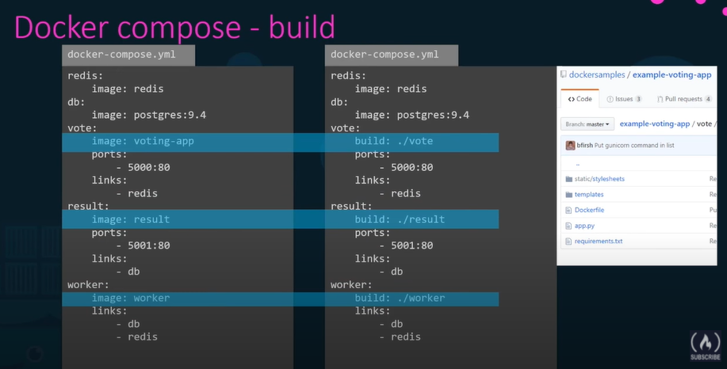

# Docker compose -versions:-

In version 1 there was no way to specify if we want to deploy containers on a different network other than default bridge network also cannot specify If we have any dependency or startup order of the container like database container must come up first only then the voting application should be started.

Some format also changed in version 2 onwards, cannot specify the stack information directory as we did in v1. It is all encapsulated in a **Service** section. We have to mention what version of docker compose file we are using.

In version 2 onwards docker compose automatically create a dedicated network for the application and attach all the containers with that network and all container communicated each other using their service name unlike in version 1 docker compose attaches all the containers to the default bridge network and use link to enable the communication between the containers as we have done.

In version 2 onward we have depends_on property where we can mention if there is any dependency on other image like container like database container must come up first only then the voting application should be started.

Version 3 comes with the support of docker swarm.

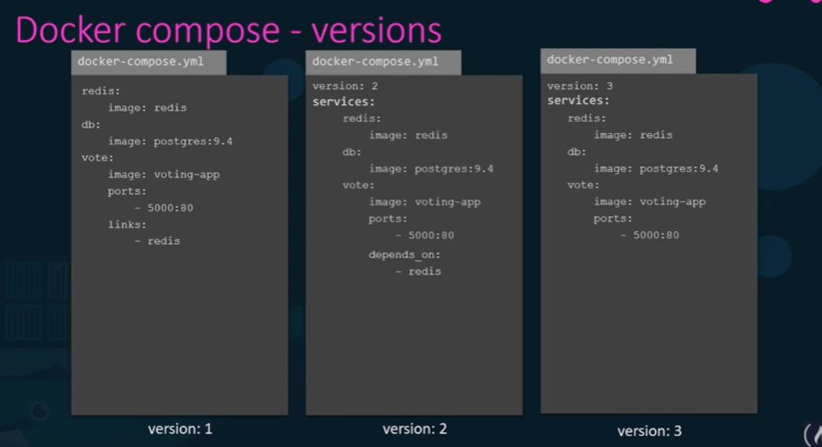

In docker compose we can create different networks for an application and connect few of the container from one network and other can connect to the second network like we connect frontend application through frontend network and backend application through backend network so that we can separate user generated traffic from internal traffic.

To create networks, we have to define a new property **networks** and mention all the network and inside service in image level we have to tell which service will be attached to which network.

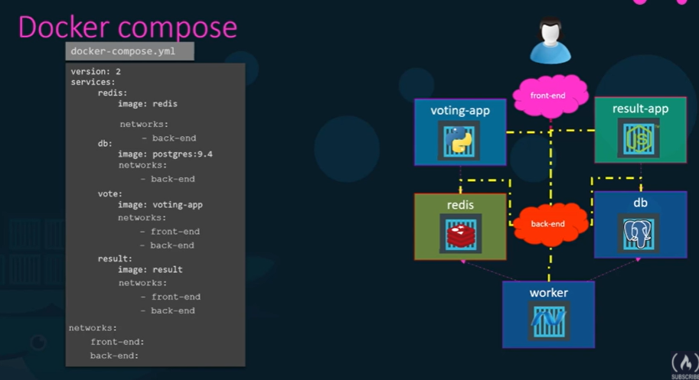

# Docker registry: -

Docker registry is a central repository of all docker images.

If we don’t specify the location where the images are to be pulled from it is assumed to be on docker default registry docker hub. Registry is the place or location where all images are stored and when we create a new image or update an existing image, we push it to the registry and when we deploy the application it pulls from the registry.

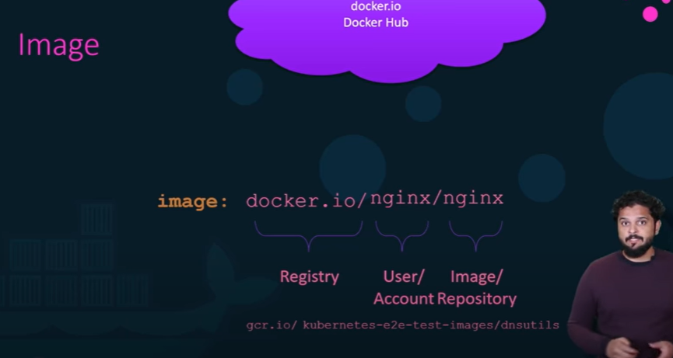

We can have our own internal private registry also multiple cloud service provides such as aws, azure, google(gcp) provide a private registry.

To access the private registry (to pull image from or to update/push image), we have to first login to the registry using credential.

**docker login private-registry.io** – to login private registry

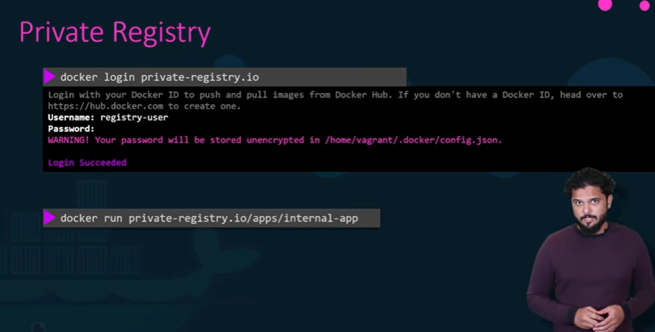

If we are running our application on premise and don’t have private registry then we can deploy our own private registry within organization. Docker registry is itself an application and available as docker image. Name of the image is registry and exposes the api on port 5000.

We can use image tag command to tag my image with the private registry URL in it. Since it’s running on same docker host we can use localhost:5000 followed by image name. We can pull the image using localhost if we are on the same host otherwise use the docker host ip address or domain name if accessing from other docker host.

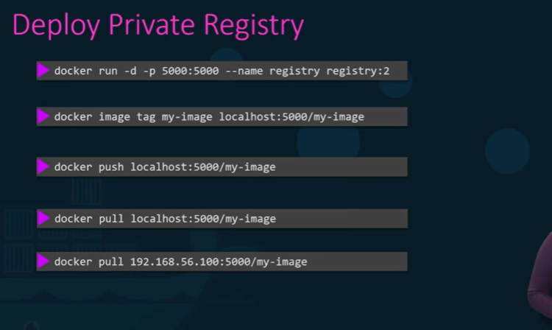

# Docker Engine: -

Docker engine simply refer a host with docker installed on it. Docker engine contains three different components.

1) Docker Deamon- It is a background process that manages docker objects such as images, containers, volumes, and networks.

2) REST API- It is a API interface that programs can use to talk to the demon and provide instructions. We can create our own tool using this rest api.

3) Docker CLI- It is nothing but command line interface that we have been using to perform action like running containers, stopping containers, destroying images etc. It uses the rest api to interact the docker demon.  
**NOTE:** Docker CLI need not necessarily be on the same host, it could be on another system and can still work with a remote docker engine by using **docker -H=remote-docker-engine:2375.**

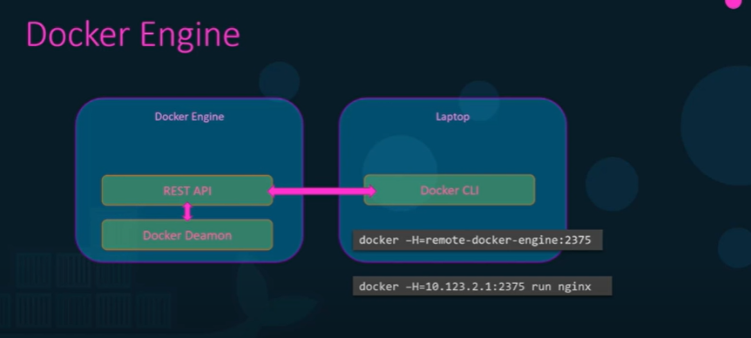

# Containerization:-

Docker uses namespaces to isolate workspace, process IDs, network, inter-process communication, mounds and unix timesharing system created in their own namespace thereby proving isolation between containers.

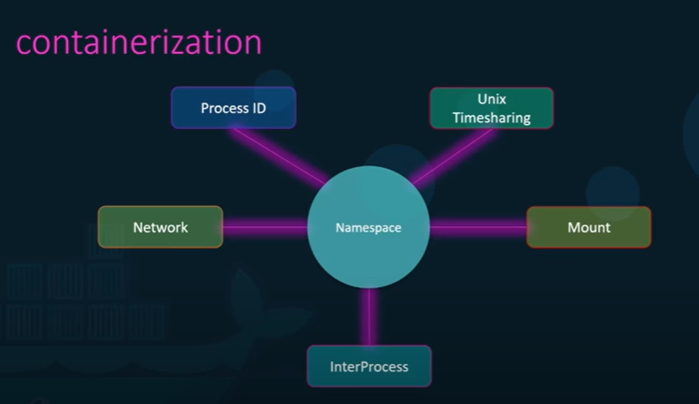

**Ps** command to see all the process running.

Container may have the same process id with the linux system or docker host but they are separated or specified by their namespace.

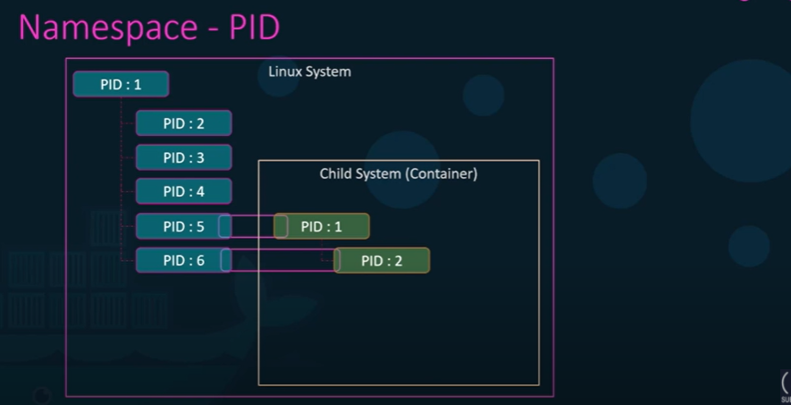

Docker host as well as containers share the same system resources such as CPU and memory. By default there is no restriction as to how much of a resource a container can use and hence may end up utilizing all the resources on the underlying host but there is a way to restrict how much resources docker container can use. Docker uses C groups or control groups to restrict the amount of hardware resources allocated to each container. This can be done by proving –cpus option in docker run command.

**docker run --cpus=.5 ubuntu –** means container does not take up more than 50% of the host cpu at any given time.

**docker run --memory=100m ubuntu –** limits the amount of memory a container can use.

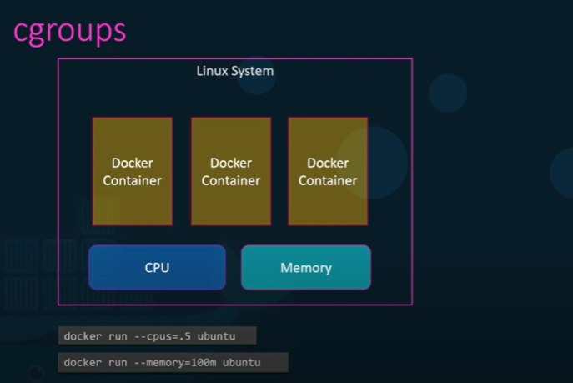

# Docker on Windows:-

Containers share the underlying OS kernel and as a result we cannot have a windows container running on linux host or vice-versa. Docker toolbox (legacy way through virtual box) and docker desktop(through hyper-v) are the two way to run docker on windows.

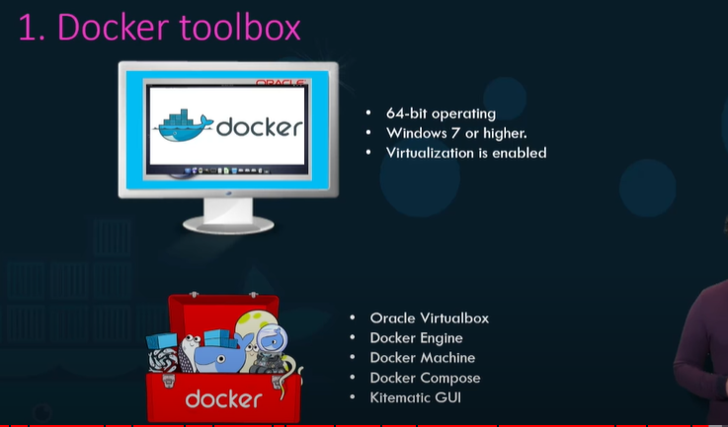

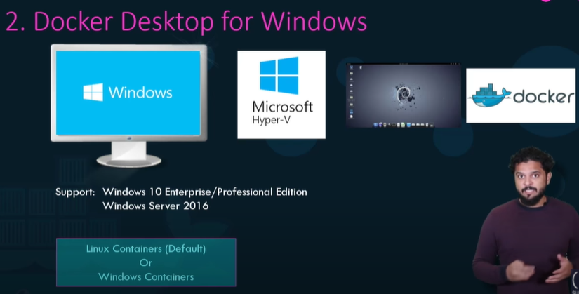

Can switch to windows container.

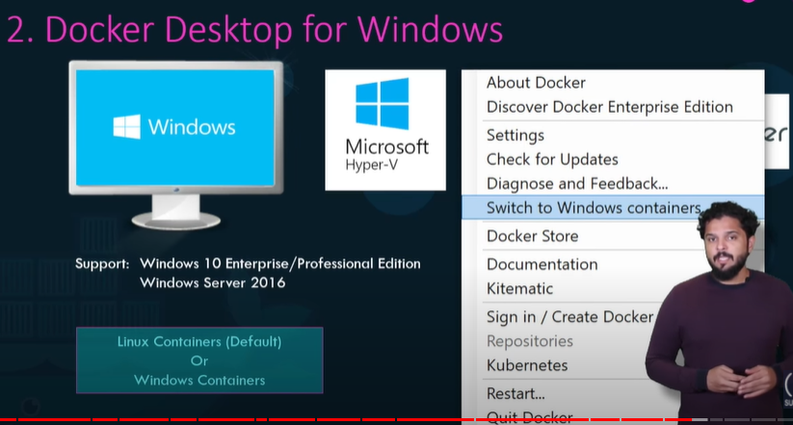

# Windows containers:

Through windows container We can create windows-based images and run windows containers on a windows server just like linux. Two types of container in windows:

1) Window server container- works exactly like linux container where the OS kernel is shared with the underlying operating system to allow better security boundary between containers and to a lot of kernels with different versions and configurations to coexist second option was introduced known as

2) hyper-v isolation- with hyper-v isolation each container is run within a highly optimized virtual machine guaranteeing complete kernel isolation between the container and the underlying host.

In windows world we have two option 1) the windows server core and 2) Nano server core just like we have ubuntu, Debian, fedory, alpine(different flavor of OS in linux).

In nano server headless deployment option for windows server which runs at a fraction of size of the full operating system though window server core is not that much light weight.

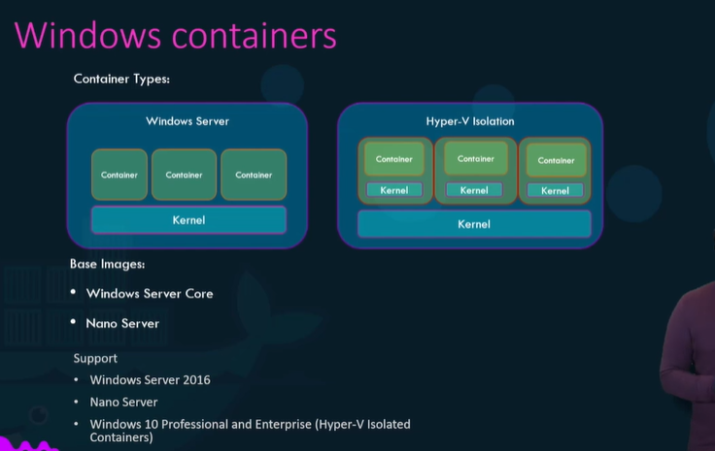

# Container Orchestration:-

It is a solution consists of a set of tools and scripts that can help host containers in a production environment typically a container orchestration solution consists of multiple docker host that can host containers that way even if one fails the application is still accessible through the others. The container orchestration solution easily allows you to deploy hundreds or thousands of instances of your application with a single command. This is command used for docker swarm. Some orchestration tools help to automatically scale up the number of instances when users increase and scale down no of instances when the demand decrease. Some solution helps in automatically adding additional host to support user load and also proved solution for advance networking, sharing , configuration management, security between these containers.

**Docker swarm**(easy to implement but lacks in some of the advanced autoscaling feature), **Kubernetes**(most popular, bit difficult to setup but provide a lot of option to customize deployment and has support for many different vendors) and **MESOS**(provided by apache, quite difficult to setup but supports many advanced features) are the solution provided for orchestration.

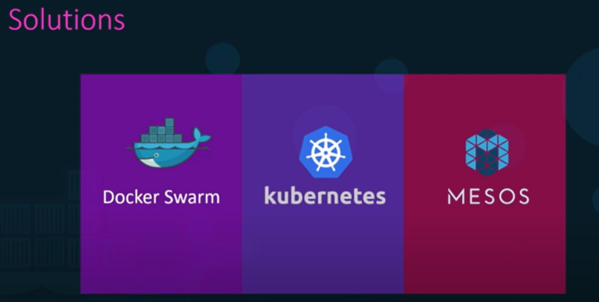

## Docker swarm:-

With docker swarm we can combine multiple docker machines together into a single cluster. Docker swarm will take care of distributing your services or your application instances into separate hosts for high availability and load balancing across different systems in hardware.

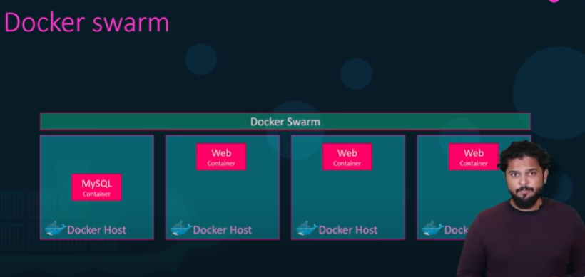

To setup docker swarm we must have multiple hosts with docker installed on them then designate one host to be the manager or the master or the swamp manager as it is called and others as slaves or workers then run **docker swarm init** command on the swarm manager and that will initialize the swarm manager and the output will also provide the command to be run on the workers. So, copy the command and run it on the worker nodes to join the manager. After joining the swarm, the workers are also referred to as nodes and we are ready to create services and deploy them on the swarm cluster.

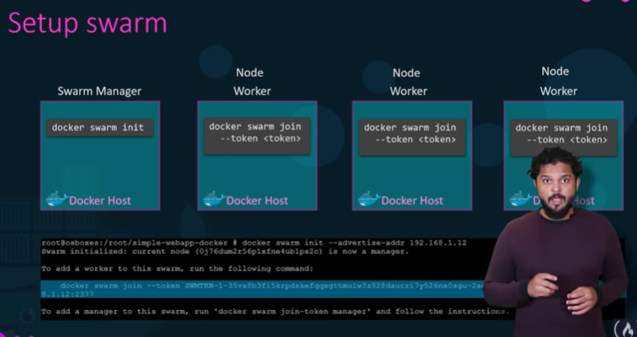

To run multiple instance of my web server, one way is to run docker run command on each worker node but to do that we have to login into each node and run this command, I have to setup load balancing, monitor each instance, and if instance fails, I have to restart. So, it is going to be impossible task. Now docker swarm orchestration does all of this for us. The key component to docker swarm is docker service. Docker services are one or more instances of a single application or service that runs across to the nodes in the swarm cluster. As a instance we can create a docker service to run multiple instance of my web server application across worker node in my swarm cluster. To do this we have to run **docker service create command** with the image name and specify the no of instance of my web server(image) by replica on manager node which will be distributed across worker node. **Ex- docker service create –replicas=3 my-web-server.**

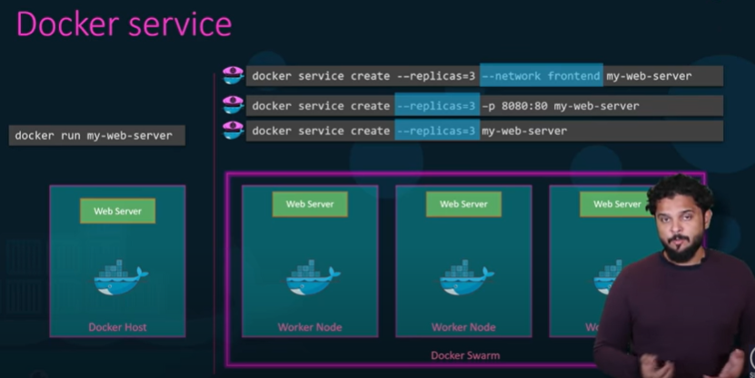

## Kubernetes:-

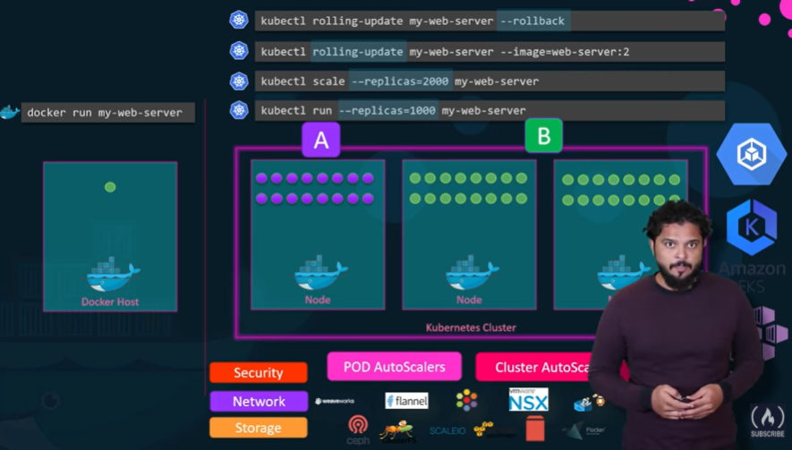

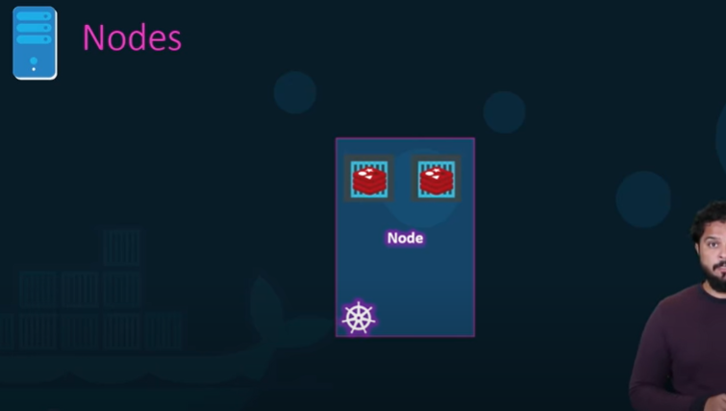

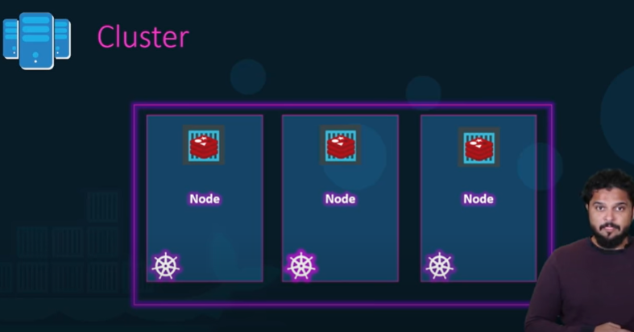

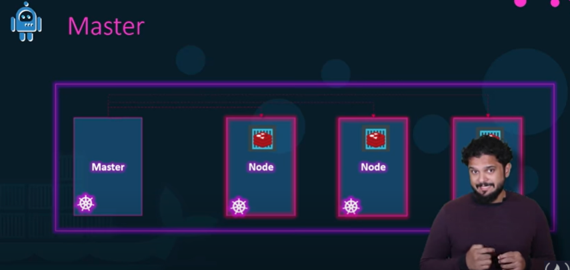

Api Server- It acts as a front-end of the Kubernetes. The users management devices, command line interfaces all talk to API server to interact with Kubernetes cluster.

Etcd- it is a distributed reliable key-value store used by Kubernetes to store all data used to manage the cluster. Like when we have multiple nodes and multiple masters in the cluster etcd stores all the information on all the nodes in the cluster in a distributed maner. Responsible for implanting lock within the cluster to ensure there are no conflict between the masters.

Scheduler- It is responsible for distributing work containers across multiple nodes. It looks for newly created containers and assigned them to nodes.

Controllers- It is the brain behind the orchestration. They are responsible for noticing and responding when nodes, containers, or endpoints goes down. Controllers makes decision to bring up new containers in such cases.

Container Runtime-It is underlying software that is used to run containers in our case it happens to be docker.

Kubelet- It is the agent that runs on each node in the cluster. The agent is responsible for making sure that containers are running on the node as expected.

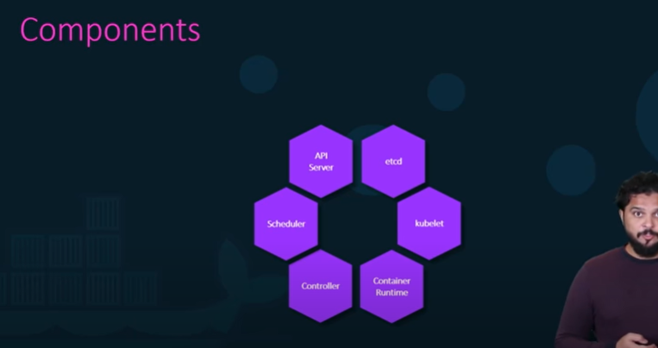

Kubectl- Kube control tool is the Kubernetes CLI which is used to deploy and mange applications on a Kubernetes cluster to get cluster related information, to get the status of the nodes in the cluster and many other thing.

**Kubectl run hello-minikube-** command is used to deploy an application on the cluster.

**Kubectl cluster-info** – To get information about custer

**Kubectl get nodes**- to get the list of nodes.

